Tripping the Light Fantastique
“Sport that wrinkled Care derives,
And Laughter holding both his sides.
Come, and trip it as you go
On the light fantastic toe.” – John Milton, “L’Allegro”, 1645

I make art because I am compelled to make art, as some are compelled to dance when they hear music. A deep and unavoidable urge drives me to create with my hands and make this world a little more beautiful. Through this process I delve deeper into my own understandings of the world around me, ideas of beauty and balance, as well as my Self. I learn a lot about what I am okay with, and not okay with during the process of creating my art.
Simple shapes and patterns inspire me, especially those found in nature, textiles, and textures. The tiny, minute, elegant, and beautiful details of the world around us is the muse for the marks and shapes in my drawings. Intricate shapes, dots, and lines combine together to make an intimately beautiful space that pulls you in close to share its poetic beauty with you. These small drawings almost seem to writhe and breathe within their frames, as if they themselves were living entities.
This series of drawings are my post-graduation explorations to get back to my roots of why I chose art. After spending the last few years at school and working almost exclusively in oil paint, I was excited to get back to something simpler, the pen. The permanence of pen is something I have always had respect for. There is something about writing in pen that makes you really consider what you are doing, having to live with any of the mistakes you make. Through these drawings I have learned a stronger sense of acceptance, and allowing my mistakes to simply “be”. Within the small imperfections of my drawings I have found incredible beauty, the wavering lines, the accidental trip over the line, the things which show this was made by a human hand. These are the things that are special to me about these drawings.

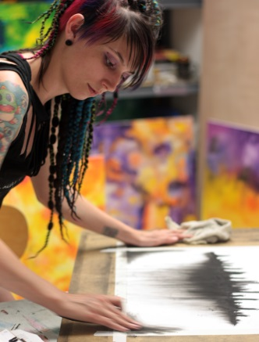
Whitney Rolfe is a recent graduate from Southern Oregon University, and has always been an Oregonian. She has always had an affinity for both the dark and the bright, having been referred to as a “dark rainbow” for both her personal style as well as her abstract art. Bright and whimsical paintings are juxtaposed with her small intricate black and white drawings. As well as making art, she also creates braid-in synthetic dreads, which you can often see her wearing.
For more information on DarcRainbow Creations, please visit:
www.darcrainbow.com or www.facebook.com/DarcRainbowCreations

